
RAJALAKSHMI INSTITUTE OF TECHNOLOGY
(An Autonomous Institution, Affiliated to Anna University, Chennai)

DEPARTMENT OF CSE (ARTIFICIAL INTELLIGENCE AND MACHINE LEARNING)
ACADEMIC YEAR 2025 - 2026
SEMESTER IV
AL23421 - MACHINE LEARNING LABORATORY
MINI PROJECT REPORT

REGISTER NUMBER | 2117240030109
NAME | PURUSOTHAMAN S
PROJECT TITLE | MOBILE APP USAGE PATTERN ANALYZER
DATE OF SUBMISSION
FACULTY IN-CHARGE | Mrs. VIJAYALAKSHMI R., M.E.

Signature of Faculty In-charge Signature of HoD

MOBILE APP USAGE PATTERN ANALYZER

INTRODUCTION:
• Mobile applications have become an integral part of daily life, generating large amounts of user interaction data.
• Analyzing app usage patterns helps understand user behavior, preferences, and engagement trends.
• Machine Learning techniques can identify patterns and predict user categories.
• This project focuses on:
- Identifying frequently used app categories
- Comparing Clustering (Unsupervised Learning) and Classification (Supervised Learning) models
- Evaluating performance of both approaches
Importance:
- Helps businesses improve app recommendations
- Enhances user experience
- Useful for targeted marketing strategies

PROBLEM STATEMENT
To analyze mobile app usage data and:
- Identify usage patterns across users
- Group users based on behavior using clustering
- Classify users into predefined categories
- Compare performance of clustering vs classification models
GOAL
• Identify most frequently used app categories
• Segment users based on usage patterns
• Build classification model for prediction
• Compare:
- Accuracy of classification
- Quality of clustering
• Provide insights into user behavior
THEORETICAL BACKGROUND:

Machine Learning Concepts:

1. Clustering (K-Means):
- Unsupervised learning technique
- Groups similar data points into clusters
Equation:
J=$\sum_{i=0}^{K}{\sum_{x∈ci}{|\left|x-μ\right||}}$²
Where:
- C_{i}= Cluster
- $μ$_{i}= Centroid

2. Classification (Decision Tree / KNN):
- Supervised learning technique
- Predicts category labels
- KNN Equation:
d(x,y)=$\sqrt{\sum{(x_{i}-y_{i})}}$²

Literature Survey:
- Studies show clustering helps identify hidden user behavior patterns
- Classification models are widely used for predicting user preferences
- Hybrid approaches improve recommendation systems

Justification
- K-Means → Best for grouping unknown patterns
- KNN / Decision Tree → Easy, interpretable classification
- Combination gives deeper insights

ALGORITHM EXPLANATION WITH EXAMPLE:
User | Social | Gaming | Productivity | Entertainment
U1 | 2hr | 1hr | 3hr | 1hr
U2 | 5hr | 2hr | 1hr | 2hr

Clustering Output:
- Cluster 1 → Productivity users
- Cluster 2 → Social media heavy users

Classification Output:
- Input → New user data
- Output → Predicted category (e.g., "Gamer")

IMPLEMENTATION CODE AND DATASET USED

Category | Description / Example
Dataset Name | Mobile App Usage Dataset
Domain | Data Analytics
Objective | Classification + Clustering
Data Source | Synthetic / Kaggle
Number of Samples | 500+ users
Data Type | Tabular
Instance Description | One user
Features (Inputs) | App usage time per category
Feature Types | Numerical
Target Variable | User type
Number of Classes | 3–5
License | Open
Version | 1.0
Python Code:
import pandas as pd
import matplotlib.pyplot as plt
from sklearn.cluster import KMeans
from sklearn.model_selection import train_test_split
from sklearn.neighbors import KNeighborsClassifier
from sklearn.metrics import accuracy_score
data = pd.read_csv("mobile_usage.csv")
X = data[['social','gaming','productivity','entertainment']]
y = data['user_type']
kmeans = KMeans(n_clusters=3)
clusters = kmeans.fit_predict(X)
plt.scatter(X['social'], X['gaming'], c=clusters)
plt.title("Clustering Output")
plt.show()
X_train, X_test, y_train, y_test = train_test_split(X, y, test_size=0.2)
model = KNeighborsClassifier()
model.fit(X_train, y_train)
pred = model.predict(X_test)
print("Accuracy:", accuracy_score(y_test, pred))
OUTPUT
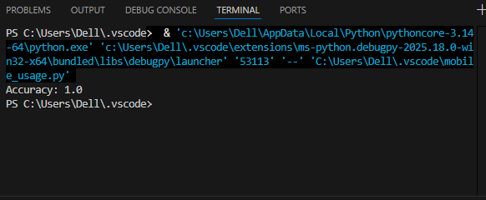
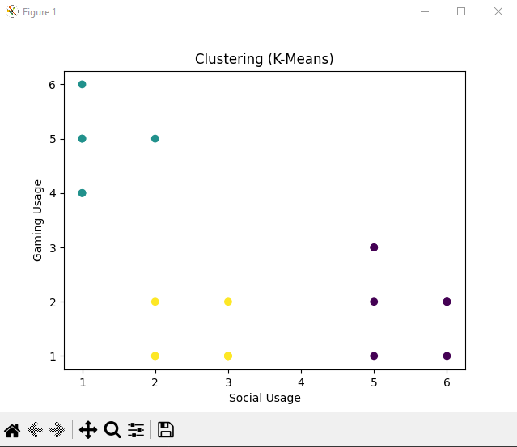
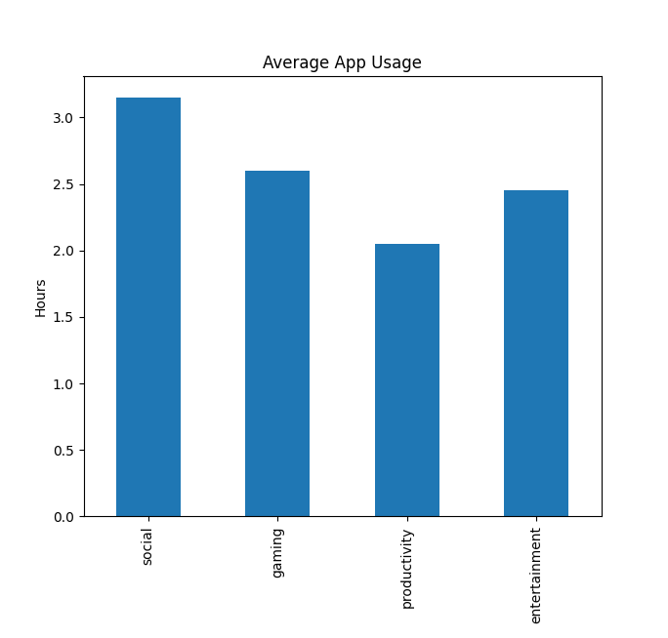
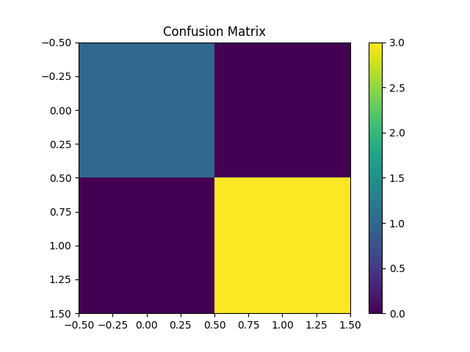

RESULTS AND FUTURE ENHANCEMENT

Results:
- Clustering identifies hidden patterns
- Classification gives accurate predictions
- Comparison shows:
  - Classification → higher accuracy
  - Clustering → better insights

Future Enhancements:
- Use Deep Learning models
- Add real-time data tracking
- Improve recommendation system
- Use larger datasets

Git Hub Link of the project along with the report
REFERENCES
- Pattern Recognition and Machine Learning
- Hands-On Machine Learning with Scikit-Learn
- Kaggle Dataset Website
- Scikit-learn Documentation
- Research papers on clustering & classification

